Exploring community resilience in Australia
Prepared by Nicholas Marinucci, Nathan Walsh, Andrew Yung
Summary
Resilience is defined as the ability to recover from and adapt to external shocks. In this article, resilience refers to a broader description of economic and social endurance despite external shocks, and not just resilience to natural hazards and disaster events.
Resilience empowers individuals, communities, organisations, and systems to thrive in the face of adversity, adapt to change, and effectively navigate the complexities of our interconnected world.
Australian regions are ranked by a resilience index which shows significant geographical variation across the country. Communities in closer proximity to major cities and regional centres have a higher level of resilience compared to more remote communities.
Findings from the index demonstrate how resilience varies geographically and what factors are causing these variations. This can help direct efforts and resources towards areas with less resilience and more vulnerability to negative impacts from external shocks.

- Defining resilience
This article introduces the concept of resilience, explains the benefits of communities and policymakers understanding resilience, and presents insights from quantitative analysis of resilience across Australia’s regions.
Resilience is a pivotal factor for communities. It bolsters long-term wellbeing, regardless of external hazards and risks. Resilience is broadly defined as a community’s ability to recover from and adapt to external shocks while maintaining its structure and functionality.
The definition of resilience can encompass a spectrum of acute or chronic external shocks. It can be tailored to a more specific scope, aligning with distinct events. For example, labour market resilience may refer to the ability to maintain a level of employment and real wages despite adverse shocks such as the closure of a firm with a large market share (Diodato and Weterings, 2015; Grabner, 2021).
In the context of climate change, resilience refers to the ‘capacity of interconnected social, economic and ecological systems to cope with a hazardous event, trend, or disturbance, responding or reorganising in ways that maintain their essential function, identity and structure’ (IPCC, 2022).
Resilience is also a term often used in relation to natural hazards and disaster events, describing how well a community can manage disaster risk through adaptation and recovery processes. It should be noted that resilience in this article refers to a broader description of economic and social endurance despite external shocks, and not just resilience to natural hazards and disaster events.
Resilience is complex. It often comprises unobservable attributes that contribute to its advancement or impede its progress. Nevertheless, understanding resilience and its driving factors can help promote policy that safeguards the sustainability of vulnerable communities.
Governments have an important role in assisting communities to understand resilience. A quantitative assessment of resilience can help state and federal governments direct support where it is needed. Understanding levels of resilience in different regions can help governments and not-for-profit organisations prioritise support for areas with less resilience. Policymakers can use insights into underlying factors that foster or hinder resilience to design well-targeted programs relevant to a community’s specific circumstances. Local councils and active community groups can benefit from a deeper understanding of resilience and the adaptive capacities of their regions and surrounds.
Section 2 of this paper discusses the value of resilience investment as opposed to recovery expenditure. Section 3 highlights the frameworks used to examine resilience, including the community capitals framework. Section 4 presents empirical analysis of resilience in Australian regions. Section 5 provides concluding remarks on the role of resilience.

- Conceptualising the value of resilience
The value of resilience is the costs avoided by a community when an external shock is realised. Resilience is closely related to recovery. Resilience and recovery can reduce the consequences of an event on a community. Resilience can also limit the direct impacts of the event. Recovery can only reduce the consequences of an event as it occurs once the event is realised. Investing in resilience can be a cost-effective way for communities to reduce the impacts of external shocks such as financial crises and natural disasters.
The Resilience Loss Recovery Curve (White et al., 2015) illustrates the different pathways of community functional capacity before and after an acute disturbance for varying levels of resilience (Figure 2.1). The red line represents a less resilient community where a shock causes greater social and economic loss. This is shown in Figure 2.1 as the area between the black line and red line. Depending on the community’s level of resilience, they may reach an equivalent functional capacity as prior to the disturbance (‘B’) or they may be left worse off (‘C’). The blue line represents a more resilient community where a shock causes less social and economic loss. This is shown by the smaller area between the black line and the blue line. A more resilient community may reach a higher level of functional capacity in the long run compared to before the acute disturbance occurred (‘A’).
              - Resilience Loss Recovery Curve
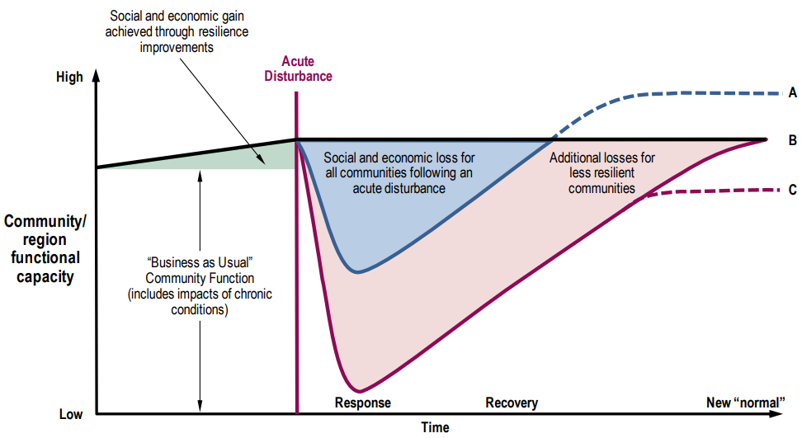
Source: White et al. (2015). Adapted from model developed by Hynes, Ross, and Community and Regional Resilience Institute (2008) and presented at the United States Department of Homeland Security University Summit, Washington, DC (Community and Regional Resilience Institute, 2008)

- Resilience frameworks
The complexities of community development and resilience have been extensively explored through various models and frameworks, often crafted by academics, non-government organisations, and development agencies.
Earlier related research predominantly from the United States includes McKnight and Kretzmann (1996) who introduced the asset-based community development framework. This framework posits that efforts to strengthen communities should focus on harnessing the capacities, skills, and assets of the community’s residents rather than using a deficit-based approach.
Community resilience is presented as an ongoing process by Norris et al. (2008), rather than a static outcome. Their perspective highlights the importance of linking adaptive capacities for successful adaptation after an adverse event. They identify economic development, social capital, information and communication, and community competence as key adaptive capacities contributing to community resilience.
Building upon the work of Norris et al. (2008), Sherrieb et al. (2010) estimate adaptive capacities related to economic development and social capital for 82 counties in Mississippi, United States, using pre-2005 population-level data. Like Norris et al. (2008), Simmie and Martin (2010) describe resilience as a sequential process that evolves over time. The authors develop an adaptive cycle model of regional economic resilience, suggesting that adaptation in regional economies follows a four-phase cycle consisting of reorganisation, conservation, exploitation and release. Each phase is related to different degrees of resilience, connectedness, and capital accumulation or loss.
Given the extensive literature on models for resilience, Serfilippi and Ramnath (2018) provide a review of resilience measurement techniques and conceptual frameworks. They categorise resilience frameworks into 3 groups: descriptive, causal and analytical. Descriptive frameworks focus on identifying key determinants without delving into causal relations and temporal factors. Causal models of resilience trace sequences of events, revealing the causal links between shocks, resilience capacities and outcomes. Analytical models build on causal models by addressing measurement complexities like aggregation, correlation and endogeneity biases.
Numerous other studies contribute to the discourse on resilience frameworks in communities and regional economies. Notable among these are works by Magis (2010), Martin (2012), Martin and Sunley (2015), and Rose (2004).
  - Community Capital Framework
Emory and Flora’s (2006) community capitals framework provides another perspective to better understand resilience. As the community capitals framework underpins the quantitative analysis of resilience in Australia presented in Section 4, it is useful to explore this framework further.
This descriptive framework proposes that the resources available to a community can be measured by 7 dimensions (community capitals). These are social, political, human, financial, cultural, natural, and built capital. A community’s development in each of these dimensions may indicate its overall living conditions and prosperity. Similarly, these community capitals can be viewed as the core foundations of resilience. The 7 community capitals are outlined below.

Social
Social capital is the interconnectedness of a community and the propensity for people to have positive interactions with one another. It also relates to people’s level of involvement in the community. Aldrich and Meyer (2014) highlight the importance of social capital in recovering from and adapting to disasters, emphasising that increasing community resilience should primarily involve strengthening social infrastructure rather than physical infrastructure. Social capital is also a central component within climate change research and adaptive capacity (Pelling and High, 2005). Social capital can be measured using observational information such as the number of people who actively volunteer. Measures of subjective wellbeing such as those reported in the Household Income and Labour Dynamics of Australia (HILDA) Survey can also be used to assess levels of social capital. Stone (2001) offers a literature review of social capital measurement and categorises measurements into either structure (networks such as families) or quality (norms such as civic/institutional trust) of social relations.

Political
Resilience is dependent on political capital because a community’s level of political capital determines the degree to which a community can act collectively and decisively during a crisis. Political capital can be reflected through the effectiveness of policy, the frequency of elections, and public trust in political systems. Aigner et al. (2001) demonstrate the importance of political capital by showing that empowering low income people through the election mechanism has a positive effect on both inclusion and citizen participation. For example, indicators like government satisfaction, as reported in Melbourne Institute: Applied Economic and Social Research’s Taking the Pulse of the Nation survey (Melbourne Institute: Applied Economic and Social Research, n.d.), can act as a proxy for political capital.

Human
Human capital describes the capabilities of people developed through their education and experiences. It is critical for the success of a community as it strongly relates to other important economic factors such as productivity and innovation. Human capital plays a central role in economic growth (Galor and Tsiddon, 1997; Mincer, 1984; Pelinescu, 2015) and other broader macroeconomic outcomes. Resilience and human capital are positively related because higher levels of human capital imply a community is in a better position to draw from its own wealth of knowledge and abilities when planning for external shocks. Human capital can be measured in a variety of ways such as the average level of educational attainment, average student test scores, or average amount of work experience in the labour force.

Financial
Financial capital refers to the community’s means to save and invest to support entrepreneurialism and wealth accumulation. This is dictated by many factors such as the financial institutions in place, the amount of opportunity to invest in safe and profitable assets, and how broader national and international economic conditions are affecting the local economy (for example, through the terms of trade of particular goods). Financial capital also underpins technological development and facilitates bursts of technological innovation through financial cycles (Perez, 2003). Financial capital provides a community with economic stability and can safeguard against external shocks.

Cultural
A community’s customs, traditions, history, and languages contribute to its cultural capital. The term was first defined by Bourdieu (1973) to explain differences in schooling performance of children in France in the 1960s. However, the concept of cultural capital has been expanded in the literature (Bourdieu, 1986; Emirbayer and Williams, 2005; Archer et al., 2015). Cultural capital influences how people interpret their environment and circumstances and, ultimately, affects how they act and associate with one another. The degree of inclusion of Indigenous communities and other culturally and linguistically diverse people contributes significantly to cultural capital. Communities with greater cultural capital are better able to leverage their diverse social assets when responding to a crisis and have a higher degree of resilience.

Natural
Natural capital represents a community’s natural endowments including climate, resources, geographic location and features, and inherent beauty. Guerry et al. (2015) discuss the importance of natural capital in the context of providing ecosystem services to inform decision-making and to improve human wellbeing. Natural capital can influence the rate of recovery and adaptation of a region impacted from external environmental shocks such as drought, flood and bushfires. It can also affect the probability of an external shock occurring within a community depending on the risk or hazard. For example, a coastal community may have higher natural capital and associated ecosystem services derived from the local beach and river. However, the same community may be more susceptible to shocks to their natural capital stock from coastal erosion and flooding.

Built
Physical infrastructure such as roads, buildings, houses, transport infrastructure, and recreation grounds is known as built capital. Access to public transport, roads, and commercial and residential buildings significantly impacts the overall standard of living in a community. For instance, access to public transport in an urban area benefits residents commuting to and from work every day or accessing essential services like health care. Brown et al. (2019) also provide evidence of the health-related benefits of improvements to public transport accessibility such as increased physical activity. Built capital is especially relevant for assessing community risk to natural disaster impacts. A community’s built environment can determine the level of exposure to these risks and the potential to mitigate the impacts of shocks.
These 7 capitals (social, political, human, financial, cultural, natural, and built) form the basis of the community capitals framework. In the context of resilience, it should be noted that not all contributing factors are identified in the community capitals framework. For example, economic diversity, government integration, and the extent of technological innovation impact a community’s degree of resilience but are not directly captured in the community capitals framework.
- Measuring resilience
  - Approaches
Quantifying a community’s level of resilience can help the design of effective policy and efficient organisation of government. A data-driven approach is a straightforward way to compare the resilience of different communities and provides insight into the factors influencing higher or lower levels of resilience.
A variety of methodologies and data have been used to measure community resilience. Sharifi (2016) provides a review of the qualitative and quantitative tools used to measure resilience in different contexts. The author identified 4 quantitative approaches to measure resilience.
- Scorecards provide values for performance against pre-determined resilience criteria.
- Indices typically use weighted averages or sums of scores for resilience criterion. The weights are often assigned subjectively using methods such as Analytical Hierarchy Process (Orencio and Fujii, 2013).
- Models use mathematical algorithms to simplify complex relationships between factors relating to resilience, such as risk, exposure, adaptive capacity, and vulnerability.
- Toolkits are a combination of scorecards, indices and models.
  - Measuring resilience in Australia
Treasury has developed an index which ranks local areas in Australia based on their degree of resilience.
The resilience index is constructed using area-level data from the Census and the Australian Early Development Census (AEDC). The data is linked through the Person Level Integrated Data Asset (PLIDA). PLIDA is a data asset that combines information on health, education, government payments, income, taxation, employment, and population demographics over time.
The index ranks Australian Bureau of Statistics (ABS) Statistical Area 2s (SA2) on their degree of overall resilience, providing an ordinal measure. The community capitals framework forms the theoretical basis for the index, using a select number of indicators to build measures of each capital domain.
Principal component analysis (PCA) is used to construct a measure of each capital using the indicator data. PCA is a statistical technique that maps a set of correlated variables to a set of uncorrelated variables (components) which represent most of the information in the original set. It is useful in reducing the dimensionality present in data. PCA is used to transform the indicator variables for a given capital into one component – the capital domain index. Previous geographic indexes have also used PCA in their construction. For example, Cassells et al. (2005) implemented PCA to calculate indexes of community capacity and need to identify regions in Australia with both high capacity and high needs. The ABS’ Socio-Economic Indexes for Areas are also derived from PCA (ABS, 2021b). The overall resilience index is then created by taking the simple average of the capital domain indexes. An unweighted average implies the assumption that all capitals contribute equally to resilience. An added benefit of this approach is that the capital domain indexes provide insight into the underlying driving factors of overall resilience in each community.
Social, human, physical, and financial capital domains are used to determine resilience. The social, human, and financial capital domains are defined in the same manner as in the community capitals framework. Physical capital typically refers to the productive capabilities of firms, however, in the context of measuring resilience it refers to the tangible assets held by individuals. Individuals’ ownership of physical assets can reflect stronger ties to a region, thus increasing community resilience.
Some capitals can be easily measured and quantified, while others require the use of proxies to be used for estimation. This is due to the nature of the capitals. For example, social capital is difficult to directly observe. However, a measure of social capital can be made by using proxies such as volunteering rates and the number of recreational sports clubs in an area. Conversely, it is less difficult to measure financial capital as contributing factors are often directly observable in data sources (for example, number of homeowners). The indicators used for each capital domain are listed in Table A1 of the Appendix.
An index approach to analysing community resilience has benefits and limitations. The main attraction of an index approach is that it combines often complex and multi-dimensional features into a singular measure that can be used to assess the relative strengths and weaknesses of an area. The ordinal nature of indexes at the regional level allows comparisons to be made between areas based on these strengths and weaknesses. However, aggregation of information comes at the cost of concealing individual-level variation. For instance, a highly resilient household may live in an area that has an overall low level of resilience. An area that is deemed to have a low level of resilience according to an index may still have a relatively high ranking of a certain factor that is considered a driver of resilience (such as social capital in the community capitals framework of resilience). A resilience index can be useful to provide information to decision makers, government, businesses, and community organisations in conjunction with information from other sources. However, an index should not be the primary or sole source of information used to make policy decisions.
  - Resilience in Australia’s regions
Figure 4.1 comprises a map of the resilience index quintiles for SA2s across Australia. Estimated resilience varies considerably by region. Communities closer to capital cities and regional centres typically have a higher degree of estimated resilience than more remote communities. The resilience index tends to be highest in the south-east area of the mainland, parts of the Western Australia coastline, and parts of coastal and central Queensland. Within these areas, there is still evidence of regional variation in resilience among local communities.
              - Resilience index, by quintiles
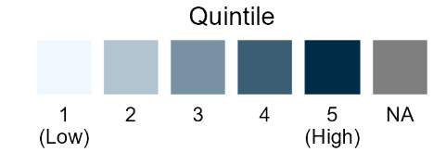
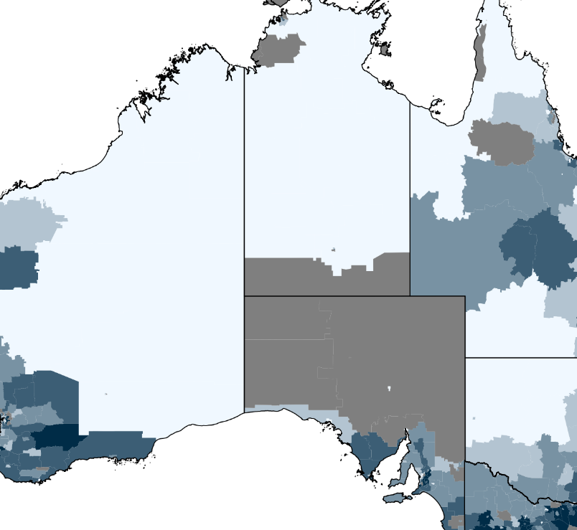
Source: Treasury analysis.
Note: Some areas are reported as NA (Not Available) due to limited data.

Resilience across states, cities and regions
The resilience index suggests that Victoria is a relatively resilient state with most SA2s placing in the top 2 quintiles. In South Australia, resilience is estimated to be highest along the coastline, especially in Adelaide and the Port Lincoln area. In Western Australia, regions along the western coast and the state’s southern coast are estimated to have high relative resilience. Across the Northern Territory measured resilience is generally low in areas outside of Darwin. In Queensland, resilience is ranked highest near the major cities located in the south-east, as well as parts of central Queensland such as the surrounds of Roma, Barcaldine, Blackall, and Longreach. In New South Wales, the resilience index is generally highest along coastal areas and in the south-east, and decreases towards the north-west corner of the state as communities become more remote. Besides built-up coastal areas such as Sydney, there are many inland areas that have a high degree of estimated resilience (for example, the broader regions surrounding Jindabyne, Berridale, Queanbeyan, Braidwood, and Yass). For the Australian Capital Territory, the resilience index is generally highest in more densely populated areas of Canberra and its surrounds. In Tasmania, communities in Hobart and Launceston rank the highest for the resilience index while regional areas usually place in the 2nd or 3rd quintiles.

Exploring the factors of resilience
An understanding of the drivers of resilience in Australian communities can be gained through analysis of the social, human, physical, and financial capital indexes depicted in Figure 4.2. Each map reflects distinct regional variation across capital domains. Different capital mixtures can also contribute to higher or lower resilience in a region. For instance, one region may score higher on the resilience index due to a high measure of social and physical capital, whereas another region may draw resilience from human and financial capital.
Social capital is geographically dispersed across Australia. Regional and remote communities typically measure as having a higher level of social capital compared to the major cities. Residents in these areas may be more likely to volunteer in their communities and connect with each other. Lower levels of access to public services in regional and remote areas may also encourage residents to form cooperative networks that facilitate sharing of time and resources. Social capital is a key determinant of resilience for many regional and remote communities across Australia.
The major cities generally have higher levels of human capital, with these areas tending to provide more opportunities for higher educational attainment as well as jobs that require a higher skill level. Outside of the major cities, most of Australia is placed in the first and second quintile of the human capital index, suggesting that human capital (as it is measured) is not a driver of resilience for these areas.
High levels of physical capital are reported across much of regional Australia, while major cities lag on this front. As the physical capital index draws on the proportion of residents who are homeowners and renters, this observation reflects that home ownership tends to be greater in regional and remote areas compared to urban areas. This may be driven in part by differences in local housing markets and accessibility to home ownership. Similar to the discussion on social capital, physical capital contributes to resilience in many regional and remote communities.
Like the human capital index, financial capital is concentrated in the major cities. This likely reflects that major cities are hubs for economic activity and generally have higher average incomes and lower unemployment rates, compared to regional and remote areas. Apart from major cities, the financial capital index is highest in parts of central Queensland, coastal Western Australia, and remote Victoria and New South Wales, potentially due to the influence of mining and agriculture on local economies.
              - Capital indexes, by quintiles
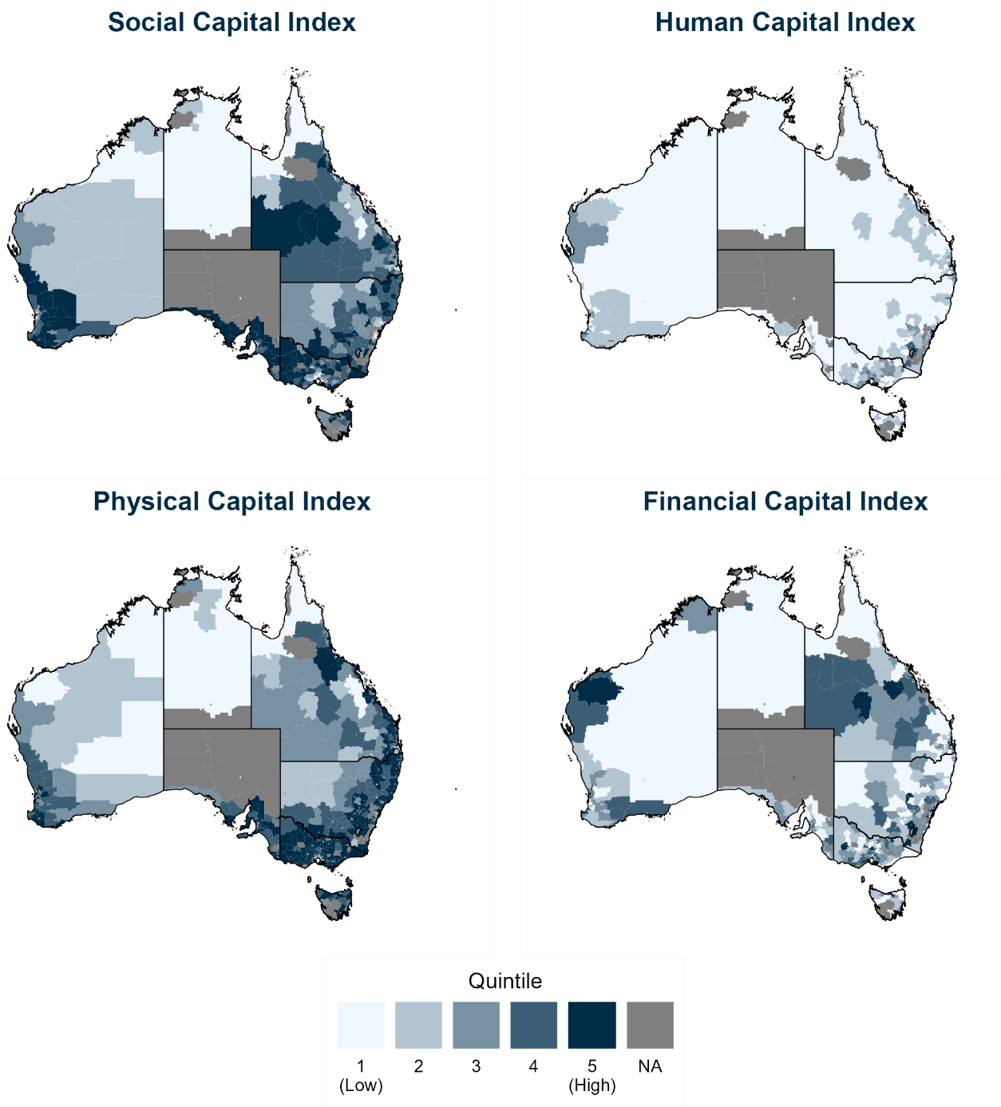
Source: Treasury analysis.
Note: Some areas are reported as NA (Not Available) due to limited data.

- Conclusion
Understanding resilience is important for communities across Australia, especially those that are more susceptible to external shocks. Together with focusing on recovery measures, communities can benefit from resilience efforts that aim to limit the direct impacts of a shock. There are numerous frameworks that have been used to better inform our understanding of resilience, including the community capitals framework.
The community capitals framework is used to develop estimates of resilience across Australia through the devlopment of a geographic index. The index conveys considerable regional variation in resilience across Australia, with areas closer to major cities and regional centres tending to rank higher compared to more remote areas. A spatial analysis of resilience can help to formulate appropriate policies that adequately address the variation in circumstances for different regions. Future analysis of resilience could be enhanced by the development of novel integrated environmental datasets that provide more informative and timely indicators of the stock of natural capital across Australia’s regions and the corresponding flow of ecosystem services.
Australia is likely to experience considerable structural shifts in the future, and so the resilience of communities to these changes will become increasingly important. The digitalisation of the economy, the growing aged-care sector, and climate change and the net zero transformation all pose unique opportunities and challenges for Australia’s regions. Understanding and improving the resilience of at-risk communities will be critical as Australia navigates through a complex economic landscape.

Appendix
Table A1 Indicators for each capital domain
Capital Domain | Indicator
Social Capital | Proportion of general practitioners in the area (Number of general practitioners/Total population)
 | Proportion of psychiatrists and psychologists in the area (Number of psychiatrists and psychologists/Total population)
 | Proportion of people involved in volunteering (Number of people who did voluntary work in the past 12 months/Number of people aged 15 years and over)
 | Proportion of people who speak English not well and not at all (Number of people who speak English not well and not at all/number of respondents)
 | Proportion of people aged 10 and under (Number of people aged 10 years and under/Total population)
 | Proportion of people aged 85 and over (Number of people aged 85 years and over/Total population)
Human Capital | Proportion of people in the area with no Year 12 certificate (Number of people without a Year 12 certificate/Number of people aged 15 and over and not in education)
 | Proportion of people in the area with a degree (Number of people with the highest level of qualifications as a degree or above/Number of people aged 15 and over and not in education)
 | Proportion of children in the area who were developmentally vulnerable on two or more domains on the AEDC (Number of children developmentally vulnerable on 2 or more domains/Total number of children in AEDC)
Physical Capital | Proportion of house renters (Number of renters/Number of occupied private dwellings)
 | Proportion of house owners (Number of owners/Number of occupied private dwellings)
 | Proportion of house purchasers (Number of purchasers/Number of occupied private dwellings)
 | Housing density (Number of houses/Area)
Financial Capital | Employment to population ratio (Number of employed people/Number of people aged 15 and over)
 | Proportion of households on low income (Number of households with income <= $25,999 per year/Number of occupied private dwellings)
 | Proportion of people unemployed (Number of unemployed people/Size of labour force)
Note: These indicators have been selected based on their relevance to the respective capital domain, as well as their statistical compatibility with the PCA that is used to construct the capital indexes. Other indicators were considered, however were not statistically viable.

References
Aigner, S. M., Flora, C. B., & Hernandez, J. M. (2001). The premise and promise of citizenship and civil society for renewing democracies and empowering sustainable communities. Sociological Inquiry, 71(4), 493–507. https://doi.org/10.1111/j.1475-682X.2001.tb01129.x
Aldrich, D. P., & Meyer, M. A. (2014). Social capital and community resilience. American Behavioural Scientist, 59(2), 254–269. https://doi.org/10.1177/0002764214550299
Archer, L., Dawson, E., DeWitt, J., Seakins, A., & Wong, B. (2015). ‘Science capital’: A conceptual, methodological, and empirical argument for extending Bourdieusian notions of capital beyond the arts. Journal of Research in Science Teaching, 52(7), 922–948. https://doi.org/ 10.1002/tea.21227
Australian Bureau of Statistics. (2021a). Australian Statistical Geography Standard Edition 3. ABS. https://www.abs.gov.au/statistics/standards/australian-statistical-geography-standard-asgs-edition-3/jul2021-jun2026
Australian Bureau of Statistics. (2021b). Socio-Economic Indexes for Areas (SEIFA): Technical Paper. ABS. https://www.abs.gov.au/statistics/detailed-methodology-information/concepts-sources-methods/socio-economic-indexes-areas-seifa-technical-paper/2021
Bourdieu, P. (1973). Cultural reproduction and social reproduction. In Brown, R. (Ed.), Knowledge, Education, and Cultural Change (pp. 56–68). Routledge.
Bourdieu, P. (1986). The forms of capital. In Granovetter, M., & Swedberg, R. (Eds.), The Sociology of Economic Life (pp. 46–58). Routledge.
Brown, V., Barr, A., Scheurer, J., Magnus, A., Zapata-Diomedi, B., & Bentley, R. (2019). Better transport accessibility, better health: A health economic impact assessment study for Melbourne, Australia. International Journal of Behavioural Nutrition and Physical Activity, 16(89), https://doi.org/10.1186/s12966-019-0853-y
Cassells, R., Taylor, E., McNamara, J., Lloyd, R. (2005). Capacity and need: A spatial analysis of Australian communities. Australasian Journal of Regional Studies, 11(3), 253–274.
Community and Regional Resilience Institute. (2008). Resilience communities, resilient regions: A resilient nation. Paper presented at the United States Department of Homeland Security University Summit, Washington, DC.
Diodato, D., & Weterings, A. B. R. (2015). The resilience of regional labour markets to economic shocks: Exploring the role of interactions among firms and workers. Journal of Economic Geography, 15(4), 723–742. https://doi.org/10.1093/jeg/lbu030
Emirbayer, M., & Williams, E. M. (2005). Bourdieu and social work. Social Service Review, 79(4), 689‍–‍724. https://doi.org/10.1086/491604
Emory, M., & Flora, C. (2006). Spiralling-up: Mapping community transformation with community capitals framework. Community Development, 37(1), 19–35. https://doi.org/10.1080/15575330609490152
Galor, O., & Tsiddon, D. (1997). The distribution of human capital and economic growth. Journal of Economic Growth, 2, 93–124. https://doi.org/10.1023/A:1009785714248
Grabner, S. M. (2021). Regional economic resilience: Review and outlook. In Wink, R. (Ed.), Economic Resilience in Regions and Organisations (pp. 21–55). Studien zur Resilienzforschung. Springer, Wiesbaden. https://doi.org/10.1007/978-3-658-33079-8_2
Guerry, A. D., Polasky, S., Lubchenco, J., & Vira, B. (2015). Natural capital and ecosystem services informing decisions: From promise to practice. Proceedings of the National Academy of Sciences, 112(4), 7348–7355. https://doi.org/10.1073/pnas.1503751112
Hynes, M. E., Ross, B, & Community and Regional Resilience Institute (2008). Resilience loss recovery curve. Washington, DC: Department of Homeland Security.
Intergovernmental Panel on Climate Change. (2022). Annex II: Glossary [Möller, V., R. van Diemen, J.B.R. Matthews, C. Méndez, S. Semenov, J.S. Fuglestvedt, A. Reisinger (eds.)]. In: Climate Change 2022: Impacts, Adaptation and Vulnerability. Contribution of Working Group II to the Sixth Assessment Report of the Intergovernmental Panel on Climate Change [H.O. Pörtner, D.C. Roberts, M. Tignor, E.S. Poloczanska, K. Mintenbeck, A. Alegría, M. Craig, S. Langsdorf, S. Löschke, V. Möller, A. Okem, B. Rama (eds.)]. Cambridge University Press, Cambridge, UK and New York, NY, USA, pp. 2897–2930. https://doi.org/10.1017/9781009325844.029
Magis, K. (2010). Community resilience: An indicator of social sustainability. Society and Natural Resources, 23(5), 401–416. http://dx.doi.org/10.1080/08941920903305674
Martin, R. (2012). Regional economic resilience, hysteresis and recessionary shocks. Journal of Economic Geography, 12(1), 1–32. https://doi.org/10.1093/jeg/lbr019
Martin, R., & Sunley, P. (2015). On the notion of regional economic resilience: Conceptualization and explanation, Journal of Economic Geography, 15(1), 1–41. https://doi.org/10.1093/jeg/lbu015
Melbourne Institute: Applied Economic and Social Research. (n.d.). Taking the Pulse of the Nation. Retrieved August 17, 2023, from https://melbourneinstitute.unimelb.edu.au/data/ttpn
McKnight, J. L., & Kretzmann, J. P. (1996). Mapping community capacity (Revised ed.). Institute for Policy Research, Northwestern University.
Mincer, J. (1984). Human capital and economic growth. Economics of Education Review, 3(3), 195‍–‍205. https://doi.org/10.1016/0272-7757(84)90032-3
Norris, F., H., Stevens, S. P., Pfefferbaum, B., Wyche, K. F., & Pfefferbaum, R. L. (2008). Community resilience as a metaphor, theory, set of capacities, and strategy for disaster readiness. American Journal of Community Psychology, 41, 127–150. https://doi.org/10.1007/s10464-007-9156-6
Orencio, P. M., & Fujii, M. (2013). A localised disaster-resilience index to assess coastal communities based on an analytical hierarchy process (AHP). International Journal of Disaster Risk Reduction, 3, 62–‍75. https://doi.org/10.1016/j.ijdrr.2012.11.006
Pelinescu, E. (2015). The impact of human capital on economic growth. Procedia Economics and Finance, 22, 184–190. https://doi.org/10.1016/S2212-5671(15)00258-0
Pelling, M., & High, C. (2005). Understanding adaptation: What can social capital offer assessments of adaptive capacity? Global Environmental Change, 15(4), 308–319. https://doi.org/10.1016/j.gloenvcha.2005.02.001
Perez, C. (2003). Technological revolutions and financial capital: The dynamics of bubbles and golden ages. Edwards Elgar.
Rose, A. (2004). Defining and measuring economic resilience to disasters. Disaster Prevention and Management, 13(4), 307–314. https://doi.org/10.1108/09653560410556528
Serfilippi, E., & Ramnath, G. (2018). Resilience measurement and conceptual frameworks: A review of the literature. Annals of Public and Cooperative Economics, 89(4), 645–664. https://doi.org/10.1111/apce.12202
Sharifi, A. (2016). A critical review of selected tools for assessing community resilience. Ecological Indicators, 69, 629–647. http://dx.doi.org/10.1016/j.ecolind.2016.05.023
Sherrieb, K., Norris, F. H., & Galea, S. (2010). Measuring capacities for community resilience. Social Indicators Research, 99, 227–247. https://doi.org/10.1007/s11205-010-9576-9
Simmie, J., & Martin, R. (2010). The economic resilience of regions: Towards an evolutionary approach. Cambridge Journal of Regions, Economy, and Society, 3, 27–43. https://doi.org/10.1093/cjres/rsp029
Stone, W. (2001). Measuring social capital: Towards a theoretically informed measurement framework for researching social capital in family and community life (Research Paper No. 24, February 2001). Australian Institute of Family Studies, Commonwealth of Australia.
White, R.K., Edwards, W. C., Farrar, A., & Plodinec, M. J. (2015). A practical approach to building resilience in America’s communities. American Behavioural Scientist, 59(2), 200–219. https://doi.org/10.1177/0002764214550296

The authors would like to thank Rebecca Cassells, Simon Ricketts, Paul Cotterill, Nathan Deutscher, Simon Nash, and Emma Richardson for their valuable comments in reviewing this paper. The views expressed are those of the authors and do not necessarily reflect those of the Australian Treasury or the Australian Government.
The HILDA Survey is a household-based panel study that provides data about economic and social wellbeing, labour market dynamics and family life in Australia. The Survey is funded by the Australian Government through the Department of Social Services and managed by the Melbourne Institute: Applied Economic and Social Research at the University of Melbourne.
PLIDA was formerly named the Multi-Agency Data Integration Project (MADIP).
SA2s ‘are designed to reflect functional areas that represent a community that interacts together socially and economically’ (ABS, 2021a).
Cultural, political, natural, and built capital are omitted for the following reasons: indicators for cultural capital are brought under the social capital domain, data for political capital is difficult to obtain within PLIDA, and natural and built capital relate just as much to exposure or risk as they do to resilience.

